Bryan Martinez

CSE 3666

10 February 2024

1)

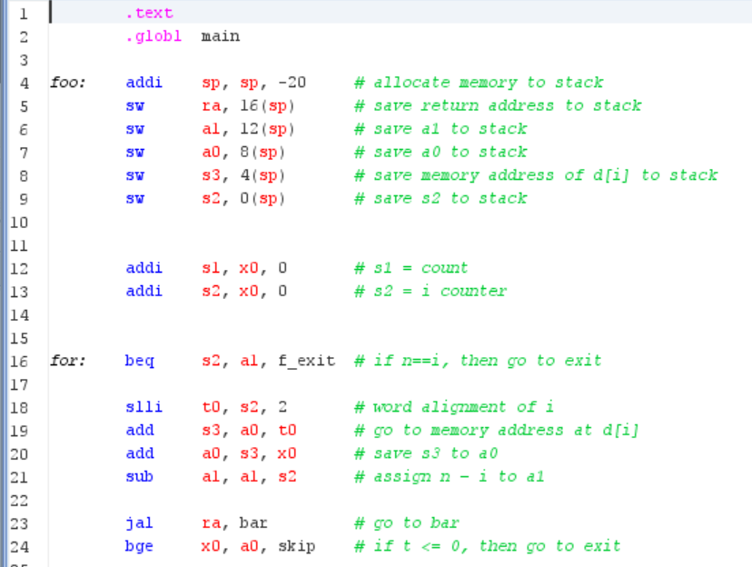

2)

3)

4)

